

Relational Database Management Systems

LAB MANUAL

Department

Of

Computer Engineering

# Neotech Faculty of Diploma Engineering

**Name: - ________________________________________________________________________________________**

**Branch: - _________________________________ Division: - _________________________________________**

**Roll No: - ___________________________________ Year: - ___________________________________________**

**NEOTECH FACULTY OF DIPLOMA ENGINEERING**

**Relational Database Management Systems(4330702)**



Neotech Faculty Of

Diploma Engineering

Virod, Vadodara.

CERTIFICATE

This is to certify that

Mr./Ms. Enrollment No._____________________ of 3nd Semester Diploma course

In has satisfactorily completed his/her termwork

In with in four walls of institute during the year 2022.

Place:

Date:

Subject Teacher Head of Department

**Subject: Relational Database Management Systems**

## Subject Code : 4330702

**LIST OF EXPERIMENTS**

|  |  |  |  |  |
| --- | --- | --- | --- | --- |
| **Sr.**  **NO.** | **TITLE OF EXPERIMENT** |  | **Date** | **Sign** |
| 1. | Implement SQL Queries to perform various DDL Commands (Create minimum 5 Tables with different data type and operate upon them). |  |  |  |
| 2. | 1. Implement SQL queries to perform various DML Commands ( Insert minimum 10 rows using different insert methods , edit and remove data using update and delete commands). 2. Retrieve data using SELECT command and various SQL operators. |  |  |  |
| 3. | Perform Queries for TCL and DCL Commands |  |  |  |
| 4. | Implement SQL queries using Data-Functions like add-month, month-between, round, nextday, truncate etc. |  |  |  |
| 5. | Implement SQL queries using Data functions like abs, ceil, power, mod, round, trunc, sqrt etc. and Character Functions like initcap, lower, upper, ltrim, rtrim, replace, substring, instr etc. |  |  |  |
| 6. | Implement SQL queries using Conversion Functions like to-char, to-date, to-number, and group Function like Avg, Min, Max, Sum, Count, Decode, etc. |  |  |  |
| 7. | Implement SQL queries using Group by, Having, and Order by clause. |  |  |  |
| 8. | Implement SQL queries using simple Case Operations and using Group Functions and Case Operations for getting summary data. |  |  |  |
| 9. | Implement SQL queries using set operators like Union, Unionall, Intersect, Minus etc. |  |  |  |
| 10. | Retrieve data spread across various table or same table using various joins. |  |  |  |
| 11. | Retrieve data from multiple tables using Subqueries (multiple Correlated). |  |  |  |
| 12. | Perform Queries to Create, alter and update view. |  |  |  |
| 13. | Implement practical-1 again with Domain Integrity, Entity Integrity and referential Constraints. |  |  |  |
| 14. | Perform Queries to create synonyms, sequence and index. |  |  |  |
| 15. | Implement PL/SQL program using control structure. |  |  |  |
| 16. | Implement PL/SQL program using cursors. |  |  |  |
| 17. | Implement PL/SQL program using exception handling. |  |  |  |
| 18. | Implement user defined procedure and functions using PL/SQL blocks. |  |  |  |
| 19. | Perform various operations on packages. |  |  |  |
| 20. | Implement various triggers. |  |  |  |
| 21. | Draw E-R diagram of the given problem statements. |  |  |  |
| 22. | Practices on Normalization – using any database perform various forms. |  |  |  |

# Practical-1

**Aim : Implement SQL Queries to perform various DDL Commands (Create minimum 5 Tables with different data type and operate upon them)**

**i. Table for student marks**

**CREATE TABLE `practical2`.`studentMarks`**

**(**

**Stdname CHAR(10) NULL,**

**Sub1 CHAR(10) NULL,**

**Sub2 CHAR(10) NULL,**

**Sub3 CHAR(10) NULL**

**);**

* **output**



**ii. Table for customer id**

**CREATE TABLE practical2.customer**

**(**

**cid varchar(3),**

**name char(10)**

**);**

* **output**



**iii. Table for Employee id**

**CREATE TABLE labmanual.employee2**

**(**

**eid varchar(3),**

**name char(10),**

**mngr_ig varchar(3)**

**);**

* **output**



**iv. Table for Employee id**

**CREATE TABLE labmanual.stdinfo**

**(**

**name varchar(10),**

**enroll_no int(10),**

**branch varchar(10),**

**semester int(1)**

**);**

* **output**



**v. Table for Employee id**

**CREATE TABLE labmanual.customerinfo**

**(**

**name varchar(10),**

**cust_no int(10),**

**product varchar(10),**

**Quantity int(1)**

**);**

* **output**



# Practical-2

1. **Implement SQL queries to perform various DML Commands ( Insert minimum 10 rows using different insert methods , edit and remove data using update and delete commands)**

**b) Retrieve data using SELECT command and various SQL operators.**

**INSERT INTO labmanual . stdinfo(name,enroll_no,branch,semester)**

**VALUES ('Veer',10,'computer',3);**

**INSERT INTO labmanual . stdinfo(name,enroll_no,branch,semester)**

**VALUES ('Rohan',01,'computer',5);**

**INSERT INTO labmanual . stdinfo(name,enroll_no,branch,semester)**

**VALUES ('Ramesh',02,'computer',3);**

**INSERT INTO labmanual . stdinfo(name,enroll_no,branch,semester)**

**VALUES ('Rahul',03,'computer',1);**

**INSERT INTO labmanual . stdinfo(name,enroll_no,branch,semester)**

**VALUES ('harsh',02,'computer',5);**

* **Output**

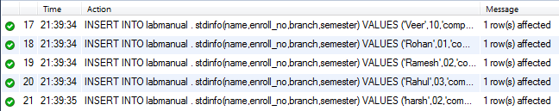

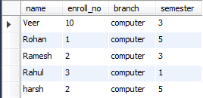

**DELETE FROM labmanual.stdinfo**

**WHERE semester = 5;**

* **Output**



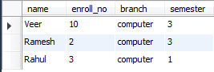

**UPDATE labmanual.stdinfo**

**SET semester = 3**

**WHERE semester = 5;**

* **Output**



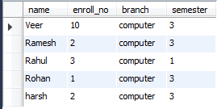

**DELETE FROM labmanual.stdinfo;**

* **Output**



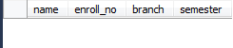

**INSERT INTO labmanual . stdinfo(name,enroll_no,branch,semester)**

**VALUES ('Rahul',03,'computer',1);**

**INSERT INTO labmanual . stdinfo(name,enroll_no,branch,semester)**

**VALUES ('harsh',02,'computer',5);**

* **Output**



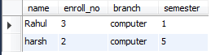

**b) Retrieve data using SELECT command and various SQL operators.**

**SELECT * FROM labmanual.stdinfo;**

* **Output**

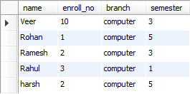

**SELECT name , semester FROM labmanual.stdinfo;**

* **Output**

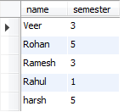

**SELECT * FROM labmanual.stdinfo**

**WHERE name = 'veer';**

* **Output**

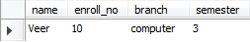

**SELECT * FROM labmanual.stdinfo**

**ORDER BY enroll_no;**

* **Output**

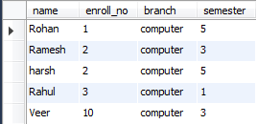

**SELECT DISTINCT semester FROM labmanual.stdinfo;**

* **Output**

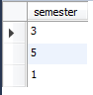

# Practical-3

**Aim : Perform Queries for TCL and DCL Commands**

* **TCL Commands**

**COMMIT;**



**ROLLBACK;**



**SAVEPOINT majama;**



* **DCL Commands**

**GRANT ALL**

**ON veer**

**TO 'user1'@'localhost';**



**REVOKE ALL**

**ON veer**

**FROM 'user1'@'localhost';**



# Practical-4

**AIM : Implement SQL queries using Data-Functions like add-month, month-between, round, nextday, truncate etc.**

* **SELECT sysdate()'present date' , adddate(sysdate(),3) FROM DUAL;**

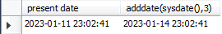

* **SELECT timestampdiff(MONTH,sysdate(),'2023-09-28');**

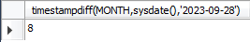

* **SELECT round(sysdate(),'DD - MON - YYYY ') FROM DUAL;**

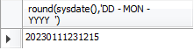

* **SELECT truncate(sysdate(),'DD-MON-YYYY HH:MI:SS PM') FROM DUAL;**

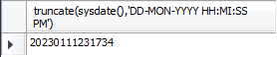

# Practical-5

**Aim : Implement SQL queries using Data functions like abs, ceil, power, mod, round, trunc, sqrt etc. and Character Functions like initcap, lower, upper, ltrim, rtrim, replace, substring, instr etc.**

* **Data Functions**
* **SELECT ABS(-25) FROM DUAL;**

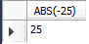

* **SELECT ceil(25.2),CEIL(25.7),CEIL(-25.2) FROM DUAL;**

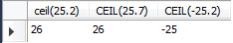

* **SELECT POWER(2,2) FROM DUAL;**

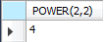

* **SELECT MOD(5,3), MOD(2,4) FROM DUAL;**

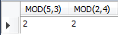

* **SELECT round(2134.567,2),round(1234.56789),round(12345.6789,-3),round(157.732,-2) FROM DUAL;**



* **SELECT TRUNCATE(12345.6789,3),TRUNCATE(12345.6789,0),TRUNCATE(12345.6789,-2) FROM DUAL;**



* **SELECT SQRT(25) FROM DUAL;**

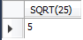

* **Character Functions**
* **SELECT lower('HELLO hOw yOu dOiNg...?') FROM DUAL;**

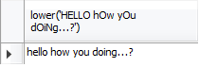

* **SELECT UPPER('HELLO hOw yOu dOiNg...?') FROM DUAL;**

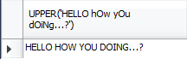

* **SELECT replace('MAJAMA_123456','123456','SHANTI') FROM DUAL;**

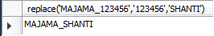

* **SELECT substr('HELLO hOw yOu dOiNg...?',7,3) FROM DUAL;**

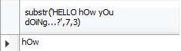

* **SELECT instr('majama','j') FROM DUAL;**

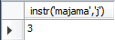

# Practical-6

**Aim : Implement SQL queries using Conversion Functions like to-char, to-date, to-number, and group Function like Avg, Min, Max, Sum, Count, Decode, etc.**

* **Conversion Function**
* **TO NUMBER**

**SELECT TO_NUMBER(‘12345’) FROM dual;**

**OUTPUT: 12345**

* **TO CHARACTER**

**SELECT TO_CHAR (123456,’09,99,999’) FROM dual;**

**OUTPUT: 1,23,456**

* **TO DATE**

**SELECT TO_DATE (‘31 DECEMBER 2012’.’DD MONTH YYYY) FROM dual;**

**OUTPUT: 31-DEC-12**

* **Group Function**
* **SELECT MAX(salary)"max salary" FROM practical2.employee;**

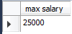

* **SELECT AVG(salary)"AVG salary" FROM practical2.employee;**

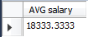

* **SELECT MIN(salary)"MIN salary" FROM practical2.employee;**

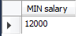

* **SELECT SUM(salary),SUM(distinct salary) FROM practical2.employee;**

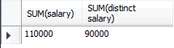

* **SELECT COUNT(*) FROM practical2.employee;**

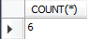

# Practical-7

**AIM : Implement SQL queries using Group by, Having, and Order by clause.**

* **Group by**
* **SELECT Stdname,sum(sub1)'total_marks1',sum(sub2)'total_marks2',sum(sub3)'total_marks3' FROM practical1 . studentmarks1**

**GROUP BY Stdname;**

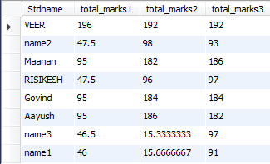

* **Having**
* **SELECT Stdname,sum(sub1)'total_marks1',sum(sub2)'total_marks2',sum(sub3)'total_marks3' FROM practical1 . studentmarks1**

**GROUP BY Stdname**

**HAVING Stdname = 'VEER';**

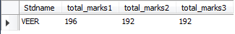

* **Order by**
* **SELECT * FROM labmanual.stdinfo**

**ORDER BY semester;**

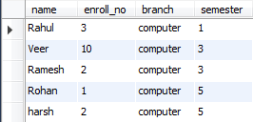

# Practical-8

**Aim : Implement SQL queries using simple Case Operations and using Group Functions and Case Operations for getting summary data.**

**SELECT bname,sum(balance)’Total balance’ FROM practical2.account**

**GROUP BY bname;**

**Output :**

**BNAME Total balance**

**Anand 7000**

**Ksad 14000**

**Vvn 11000**

# Practical-9

**Aim : Implement SQL queries using set operators like Union, Unionall, Intersect, Minus etc.**

* **SELECT name FROM practical2.customer**

**UNION**

**SELECT name FROM practical2.employee2;**

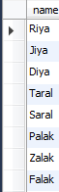

# Practical-10

**Aim : Retrieve data spread across various table or same table using various joins.**

* **Cross Join**
* **SELECT * FROM practical2.customer,practical2.employee1;**

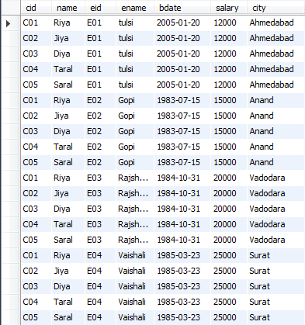

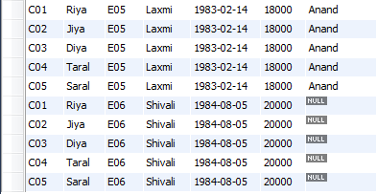

* **Self Join**
* **SELECT Emp.eid, Emp.name'EmpName', Mngr.name'MngrName' FROM practical2.employee2 Emp, practical2.employee2 Mngr**

**WHERE Emp.mngr_ig = Mngr.eid;**

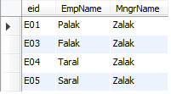

* **Outer Join**
* **SELECT id ,College.name 'NAME',department, hostel_name,room_no**

**FROM college,hostel**

**WHERE college.name = hostel.name;**

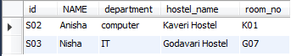

# Practical-11

**Aim : Retrieve data from multiple tables using Subqueries (multiple Correlated)**

* **select balance from practical2.account**

**where ano IN (**

**select ano from account_holder**

**where cid = 'C01'**

**);**

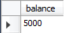

* **select balance from practical2.account**

**where ano IN (**

**select ano from practical2.account_holder**

**where cid IN (**

**select cid from practical2.customer**

**where name = 'jiya'**

**)**

**);**

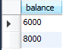

* **select ano , balance , bname from practical2.account acc**

**where balance IN(**

**select max(balance) from practical2.account**

**where bname = acc.bname**

**);**

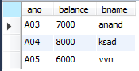

# Practical-12

**Aim : Perform Queries to Create, alter and update view**

* **Create view**
* **CREATE VIEW Acc_vvn**

**AS SELECT * FROM practical2.account**

**WHERE bname = 'vvn';**



* **Alter view**
* **ALTER VIEW acc_vvn**

**AS SELECT * FROM practical2.account**

**WHERE bname = 'ksad';**



* **Update view**
* **UPDATE acc_vvn**

**SET bname = 'vvn';**



# Practical-13

**Aim : Implement practical-1 again with Domain Integrity, Entity Integrity and referential Constraints**

* **Domain Integrity**
* **CREATE TABLE practical2.account2**

**(**

**ano char(3),**

**balance int(9) NOT NULL,**

**bname varchar(10)**

**);**



* **Entity Integrity**
* **CREATE TABLE practical2.account3**

**(**

**ano char(3) UNIQUE,**

**balance int(9) ,**

**bname varchar(10)**

**);**



* **Referential Integrity**
* **CREATE TABLE practical2.account5**

**(**

**ano char(3) primary key,**

**balance int(9) ,**

**bname varchar(10)**

**REFERENCES Branch (bname)**

**);**



# Practical-14

**Aim : Perform Queries to create synonyms, sequence and index**

* **Synonym**
* 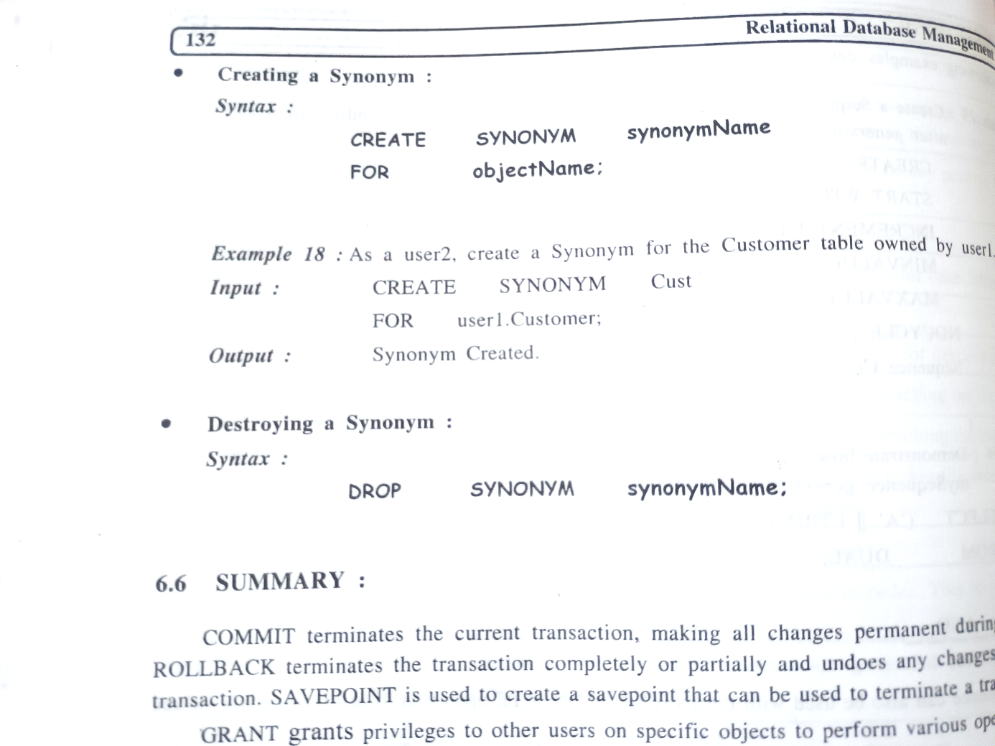

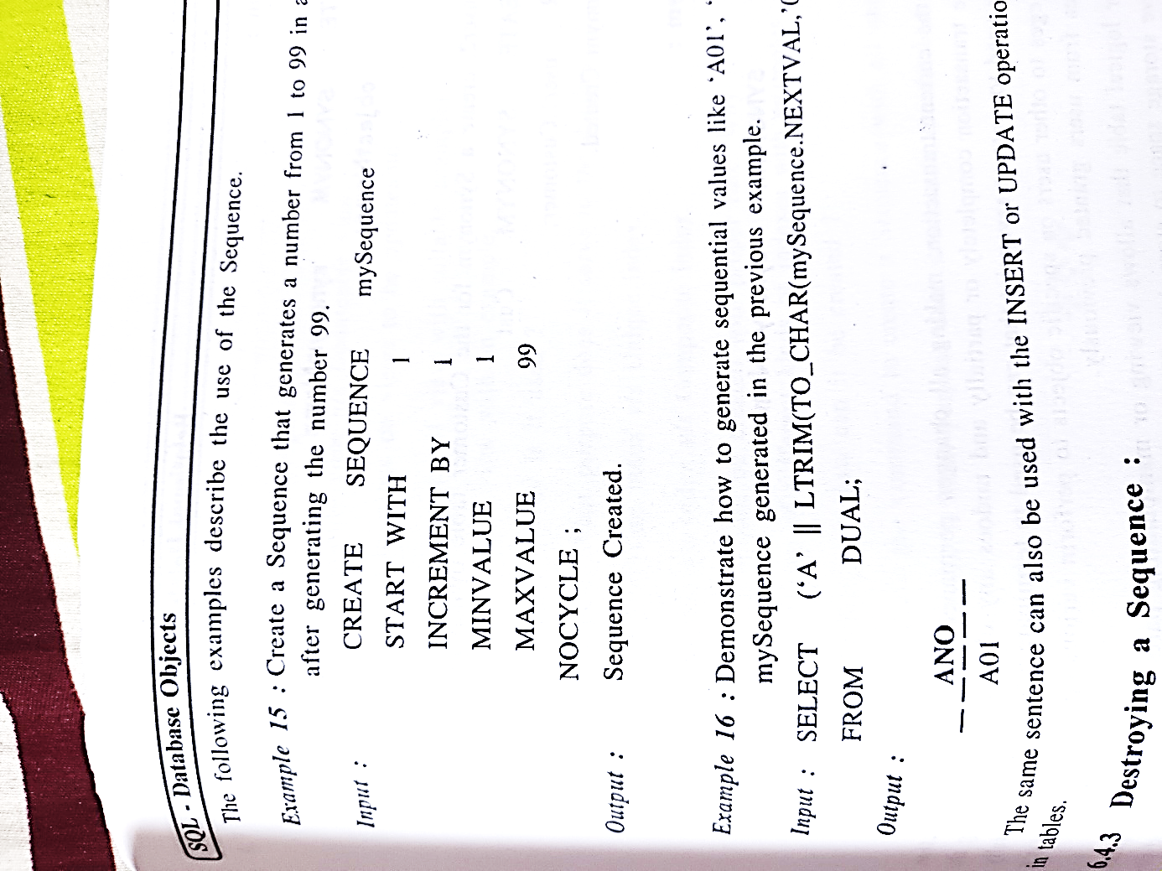

* **Sequence**
* **Index**
* **CREATE INDEX indcustname**

**ON practical2.account(ano);**



# Practical-15

**Aim : Implement PL/SQL program using control structure.**

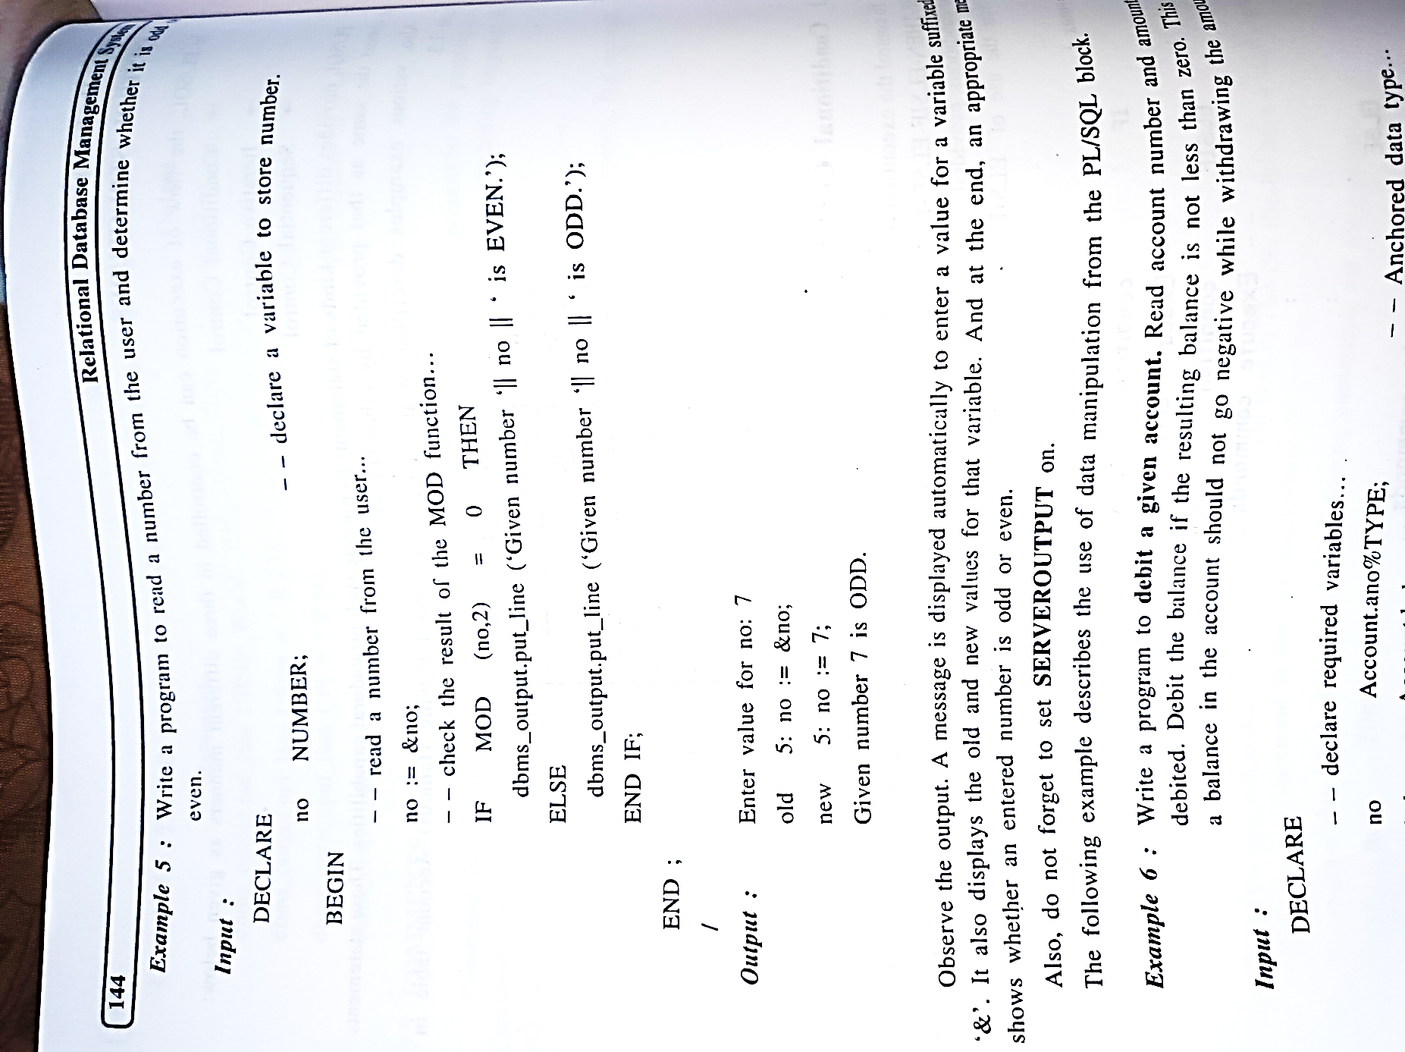

# Practical-16

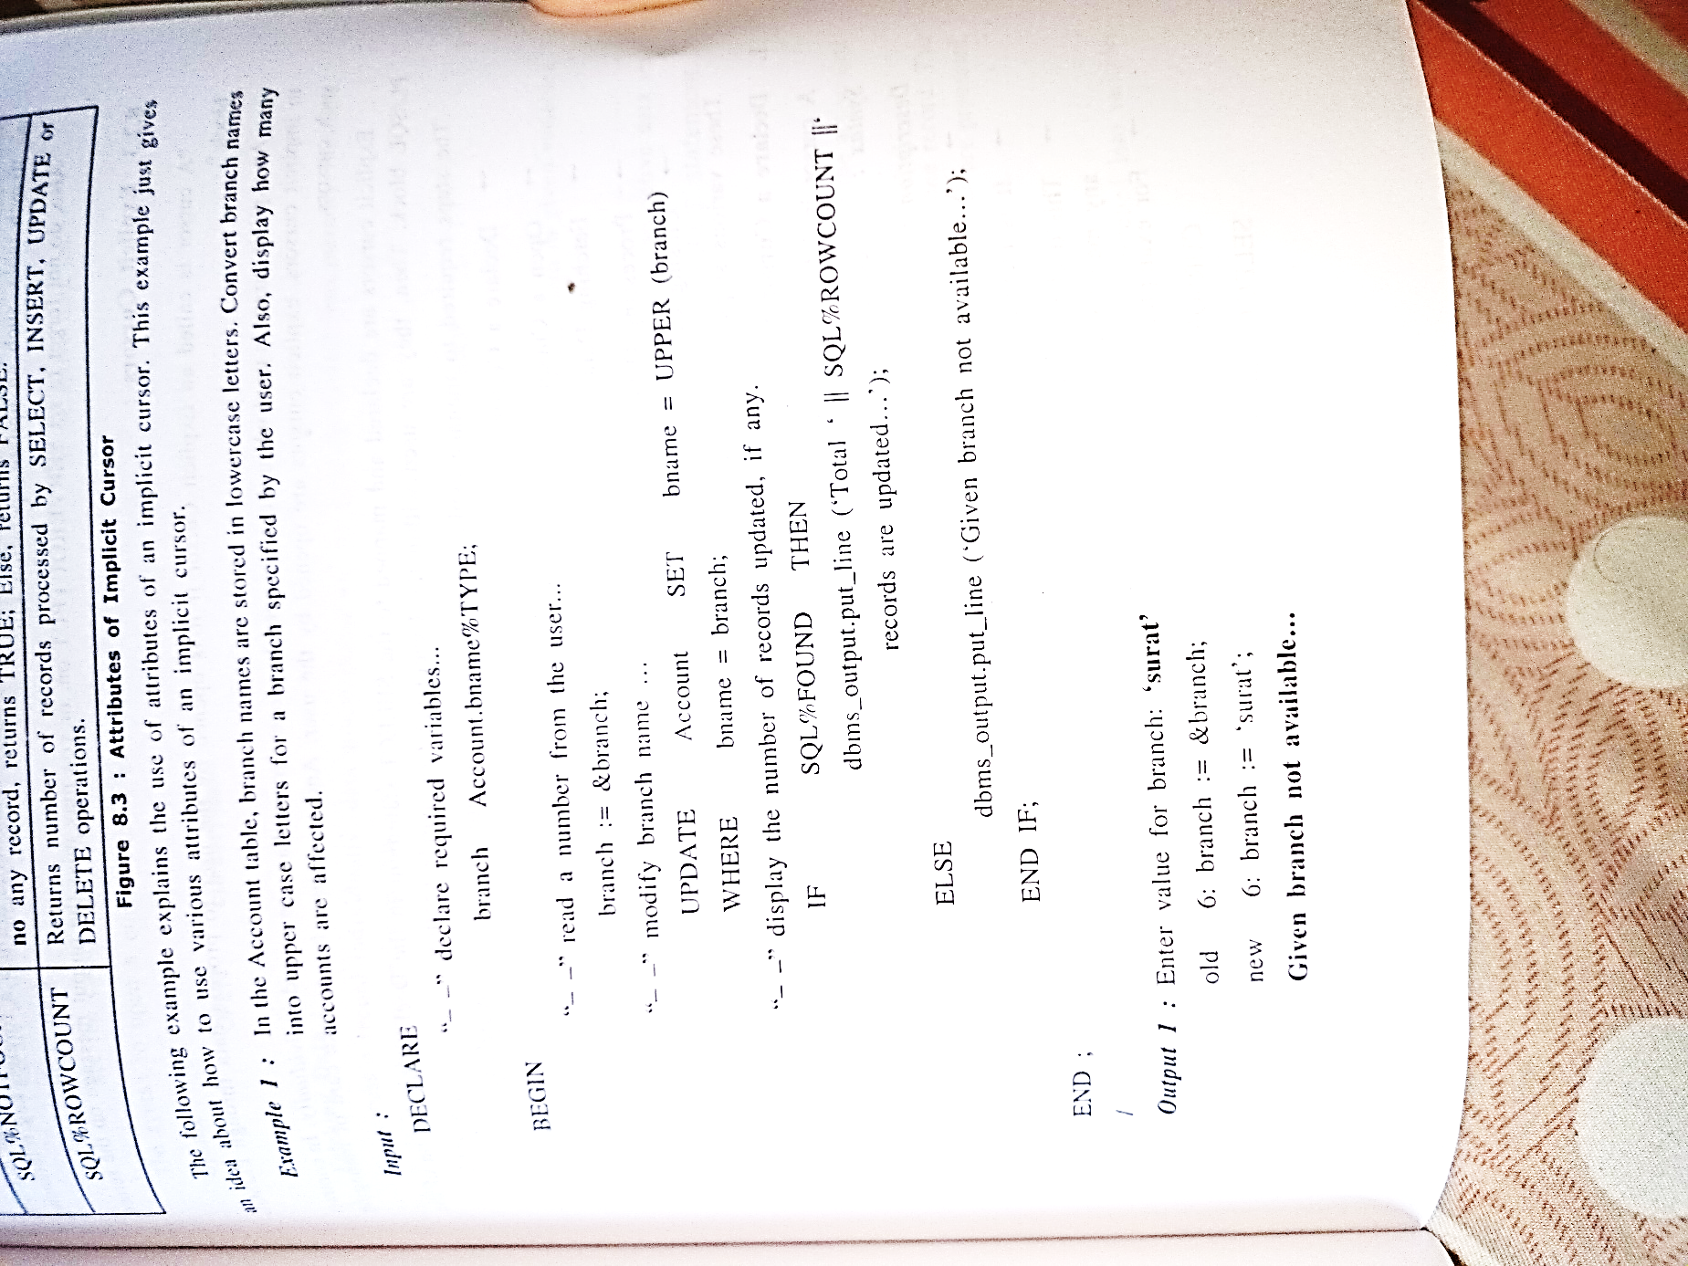**Aim : Implement PL/SQL program using cursors.**

# Practical-17

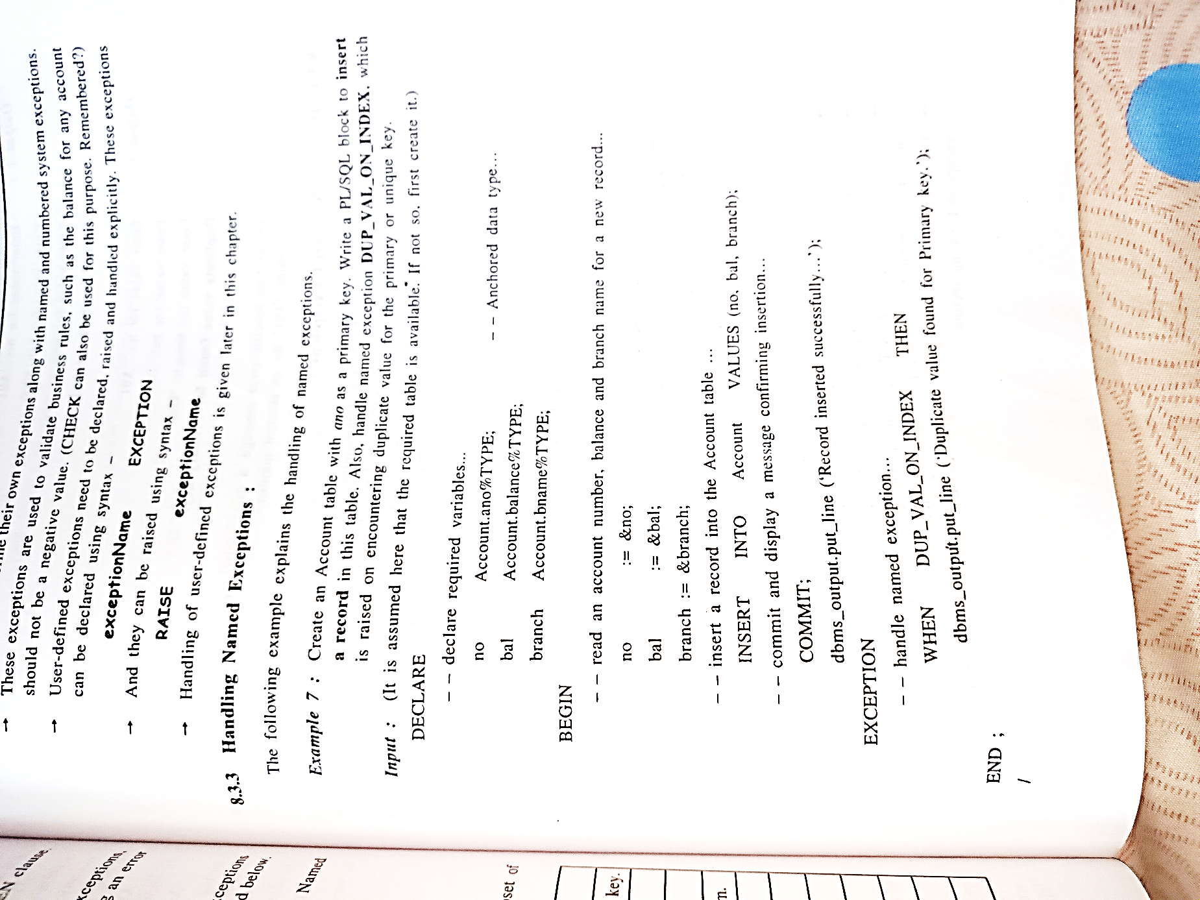**Aim : Implement PL/SQL program using exception handling.**

**Enter value for no: ‘A01’**

**Enter value for no: 5000**

**Enter value for no: ‘vvn’**

**Record inserted successfully…**

# Practical-18

**Aim : Implement user defined procedure and functions using PL/SQL blocks.**

* 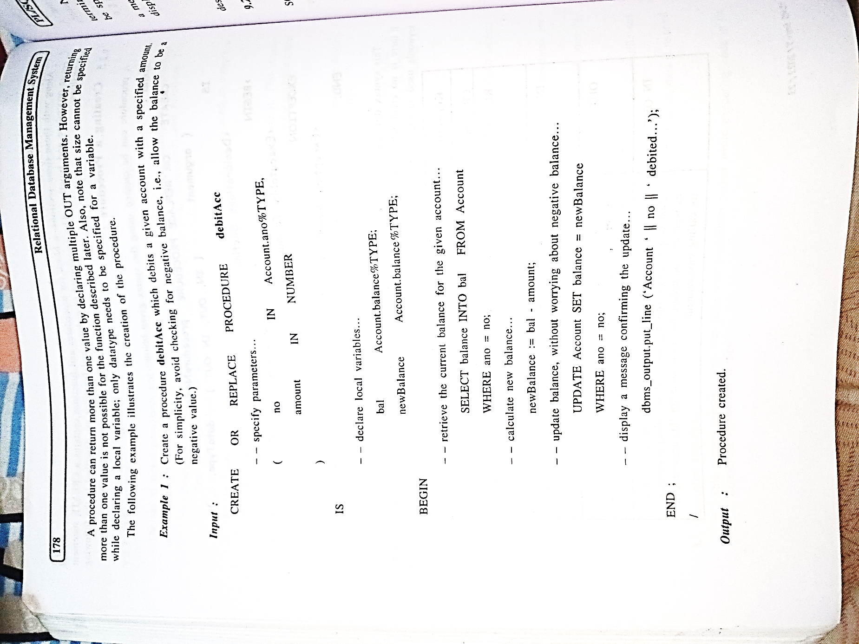
* **Executing a procedure**

**debitAcc(‘A01’,1000);**

**output : Account A01 debited**

* **Creating function**

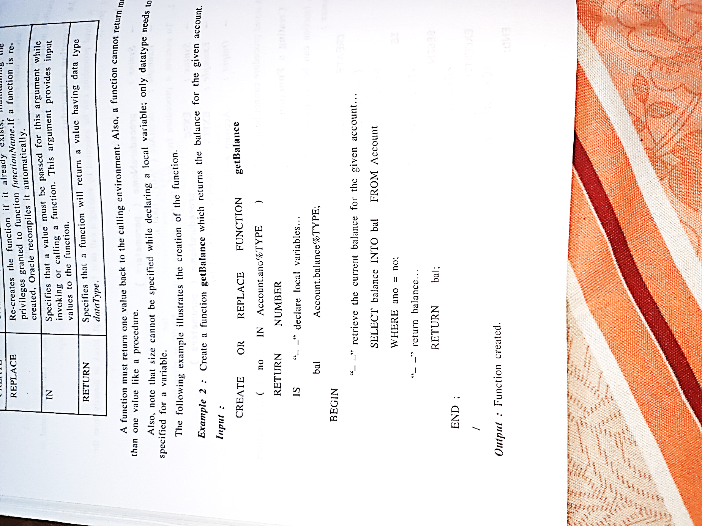

* **Destroying Procedure and Function**

**DROP PROCEDURE debitAcc;**

**Output: Procedure drop**

**DROP FUNCTION getbalance;**

**Output: Function drop**

# Practical-19

**Aim : Perform various operations on packages.**

* **Creating Package**

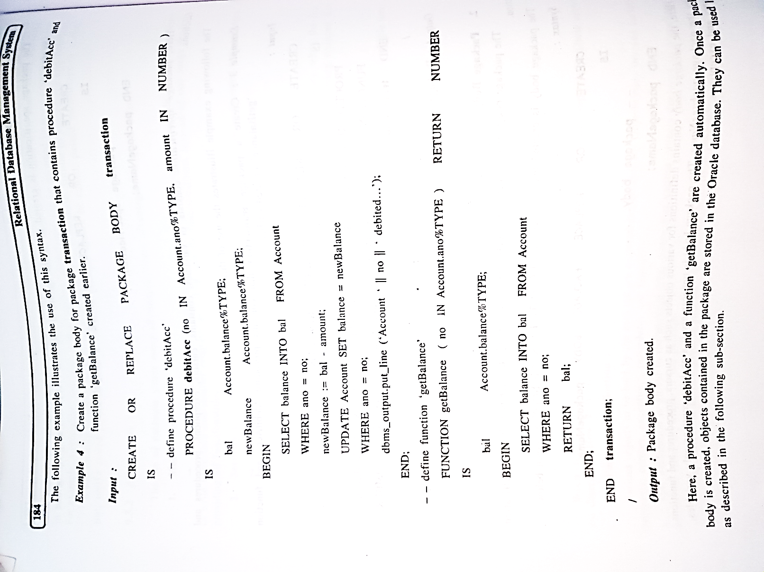

* **Referencing a package subprogram**

**SELECT transaction.getBalance(‘A01’) FROM dual;**

**Output : transaction.getBalance(‘A01’)**

**4000**

* **Destorying package**

**DROP PACKAGE tranction;**

**Output : package dropped**

# Practical-20

**Aim : Implement various triggers.**

* **Creating Trigger**

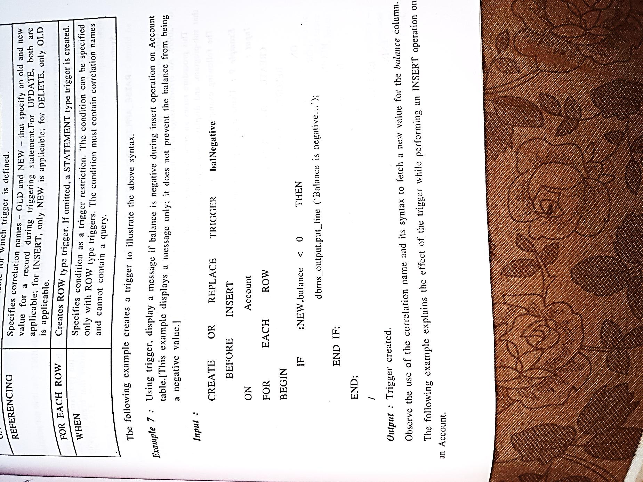

* **Destroying trigger**

**DROP TRIGGER balNegative;**

**Output : Trigger dropped**

# Practical-21

**Aim : Draw E-R diagram of the given problem statements.**

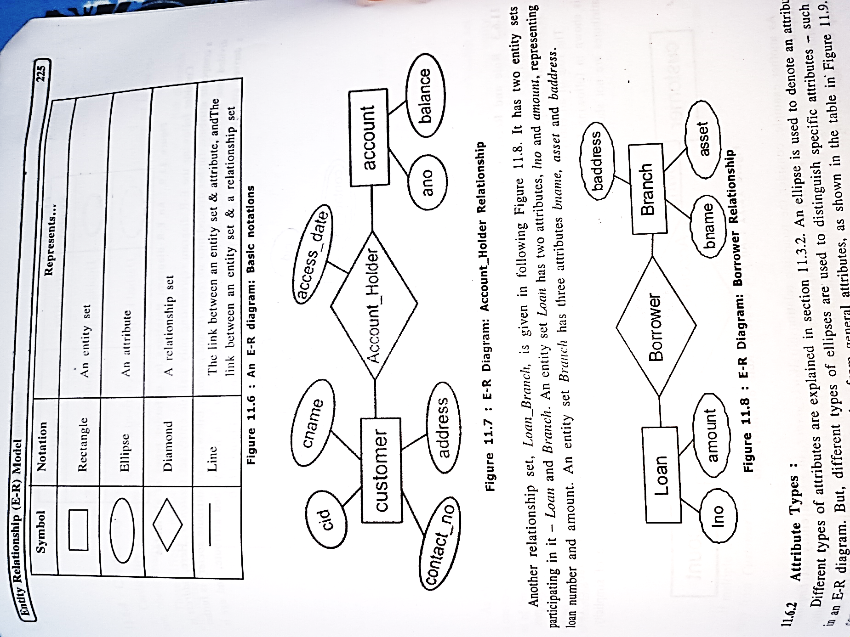



# Practical-22

**Aim : Practices on Normalization – using any database perform various forms.**

